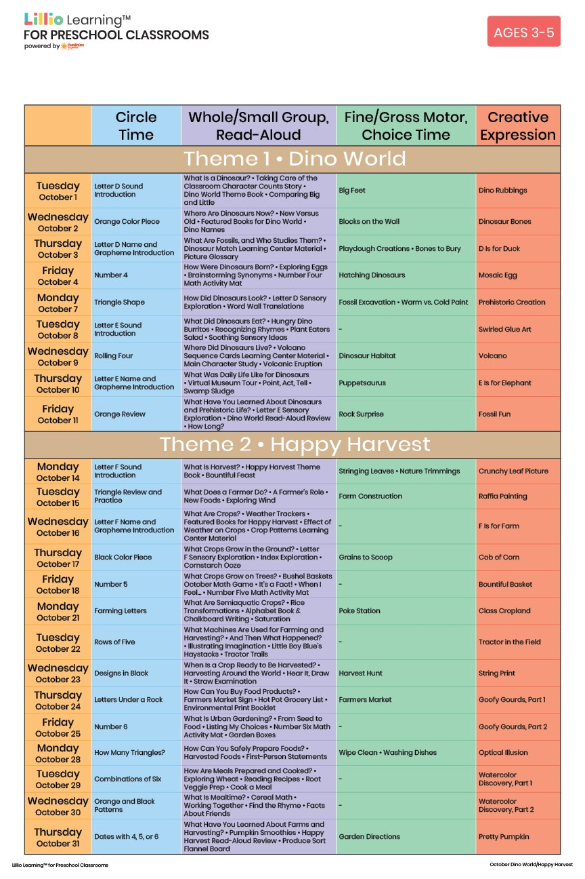

October 2024

Add Your Name/Logo Here